|  |
| --- |
| Photo displaying partial image of two pie charts on a canvas-textured page |
| Data Analysis Case Study  *Changes in Part-Time Employment in The NSW Public Sector Clusters* |
| |  |  |  | | --- | --- | --- | | Jason Ha | 12/19/19 | NSW Government Virtual Internship | |

Contents

Introduction 2

Trend Over Time in Male and Female Employment 2

Projection into 2025 3

Possible Reasons for Trends in Part-Time Employment 3

Current Representation of Part-Time Employees in Each Cluster 4

Proportion of Male and Female Part-Time Employees in The Respective Gender Workforce 5

Projection into 2025 6

Appendices 7

Appendix A 7

Appendix B 8

8

8

Appendix C 9

9

9

10

10

11

11

12

12

13

13

Bibliography 14

# Introduction

One of the growing trends in the Australian labour market is the increase in part-time employment across the public and private sectors [1]. The definition of *part-time employment*, according to the Australian Bureau of Statistics, is working less than 35 hours across all jobs in a usual working week [2]. The NSW Public sector contributes to a significant portion of the part-time employment share in NSW where 27.6% of the total headcount of people in the public sector are part-time employees (PTEs) [3]. In this report, we analyse headcount data for part-time employees in each of the following *clusters* in the public sector:

|  |  |
| --- | --- |
| * Education * Family & Community Services * Finance, Services & Innovation * Health * Industry | * Justice * Planning & Environment * Premier & Cabinet * Transport * Treasury |

The report examines the current (2018) aggregate representation of PTEs, the representation in each cluster and the proportion of female and male PTEs in each sector with respect to the total male and female workforce populous in each cluster. The change in the headcount for PTEs in each sector is also explored during the 2014-2018 period which leads to a prediction of the PTE headcount in 2025 should the predicted trends continue.

# Trend Over Time in Male and Female Employment

The data for the aggregate full-time (FTE) and part-time employment across all clusters and agencies shows that, overall, there are more female employees in the NSW public sector than there are males in the 2014-2018 period. This is evident in Figure 1 and Figure 2 which show an overall offset between the male and female part-time employment headcount throughout the period, particularly for the aggregate part-time employment where the difference in the female and male headcount is approximately 72,682 employees on average. Alternatively, female part-time employees make up 84.3% of the PTE workforce. The male-female distribution for FTES is a more even showing that males make up 43.0% of the full-time workforce in the public sector while females make up a 57.0% share.

Figure : Aggregate Male and Female FTEs employed by the public sector. The number of female full-time employees across all clusters is greater than male employees by 37,626 employees.

Figure : Aggregate Male and Female FTEs employed by the public sector. The number of female full-time employees across all clusters is greater than male employees by 72,682 employees.

## Projection into 2025

A closer examination into the part-time employee headcount for males and females shows an overall linear increase where by 2025, the male and female PTE headcounts will reach 38342 and 93909 employees respectively. This trend is shown in Appendix B in Figure Figure 9 and Figure 10 respectively. It should be noted that the female PTE headcount in the 2014-2018 was oscillatory as opposed to the male PTEs.

The male FTE trend, on the contrary to the male PTE headcount, exhibited a decreasing trend from 2014 to 2018 as is shown in Appendix A in Figure 7 and Figure 8. It is predicted that the number of male full-time employees in the public sector will decrease to 92263 employees. The trend for female FTEs shows a sharp decrease from 156793 employees to a minimum of 152038 employees in the 2014 – 2015 interval. 2015 – 2018 shows steady increase in FTEs once more and assuming a linear trend, we predict that by 2025, there will be 163424 employees across the sector.

## Possible Reasons for Trends in Part-Time Employment

Cassidy and Parsons [1] suggest that the reason for the steady increase in part-time employment can be attributed to people accommodating for full-time education (high-school or tertiary), personal preference for part-time hours and caring for children. This especially consistent with not only the increase in female PTEs but the overall higher offset of female PTEs relative to male PTEs. The participation in post-secondary education is also consistent with the simultaneous increase in both male and female PTEs ever since reforms to education when imposed in the 1980s [1].

# Current Representation of Part-Time Employees in Each Cluster

Figure 3 shows the current (2018) percentage distribution of all part-time employees in each cluster in the NSW public sector with respect to the total aggregate workforce in the entire public sector. The transport, education, justice, family and community services as well as health clusters serve have the largest share of part-time employees. However, it should be noted that the distribution in 2018 does not reflect the distributions for all years prior where certain clusters fluctuated in their part-time employee headcount share. Figure 4 and Figure 5 show the change in this distribution from 2014 to 2017.

Figure : Percentage distribution of part-time employees in 2018 in each cluster in the public sector.

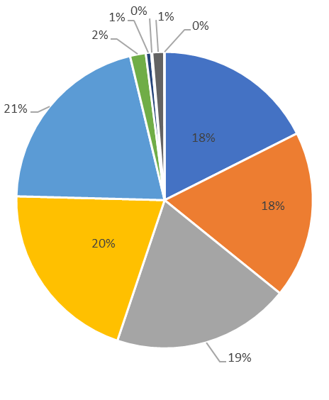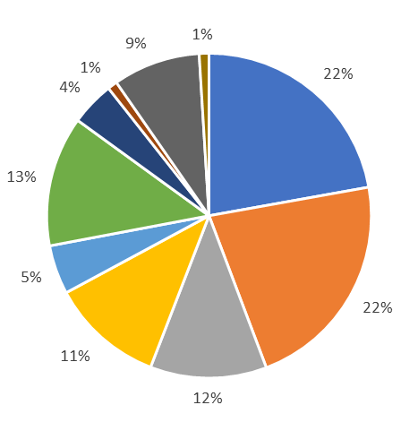

Figure : Percentage distribution of part-time employees in each cluster for 2014 (LEFT) and 2015 (RIGHT)

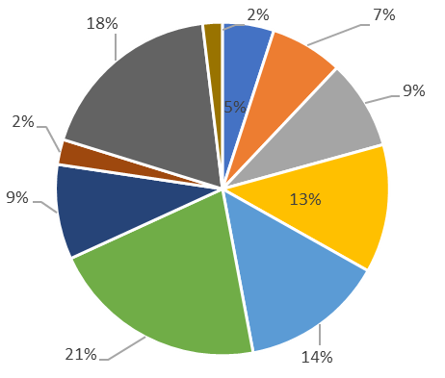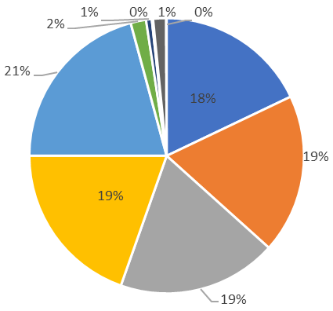

Figure : Percentage distribution of part-time employees in each cluster for 2016 (LEFT) and 2017 (RIGHT)

# Proportion of Male and Female Part-Time Employees in The Respective Gender Workforce

Figure 10 summarises the current representation of the male and female part-time employees as a percentage of the total workforce for each respective gender. Across all clusters, the number of female part-time employees is greater than that of males.

Figure : Bar graph comparing male and female part-time employees for 2018 as proportions of the male and female gender workforce in a cluster.

## Projection into 2025

The proportions, like the percentage distributions in Page 4, are not constant throughout the 2014-2018 period but rather go through fluctuations. Appendix C shows the trends in the male and female part-time proportions for each cluster in the NSW public sector over the course of the period. Assuming a linear trend for all clusters, we can see that for the *Family and Community Services* and the *Industry* cluster, we have projected negative proportions for male and female PTEs.

However, for the rest of the clusters, Table summarises what the expected proportions are for the male and female PTEs and whether the project is a result of a linearly increasing or decreasing trend.

|  |  |  |  |  |
| --- | --- | --- | --- | --- |
| **Cluster** | **Predicted 2025 Proportion (%)** | | **Trend** | |
| **Male** | **Female** | **Male** | **Female** |
| *Education* | *95.3435* | *47.4751* | Constant | Increasing |
| *Finance, Services & Innovation* | 53.0314 | 49.1676 | Increasing | Increasing |
| *Health* | *28.3746* | *40.1146* | Increasing | Constant |
| *Justice* | *11.9493* | *18.0603* | Increasing | Decreasing |
| *Planning & Environment* | *5.57925* | *22.9007* | Constant | Constant |
| *Premier & Cabinet* | *2.69776* | *15.1792* | Decreasing | Constant |
| *Transport* | *28.8881* | *7.99556* | Increasing | Decreasing |
| *Treasury* | *3.12752* | *9.26658* | Constant | Increasing |

# Appendices

## Appendix A

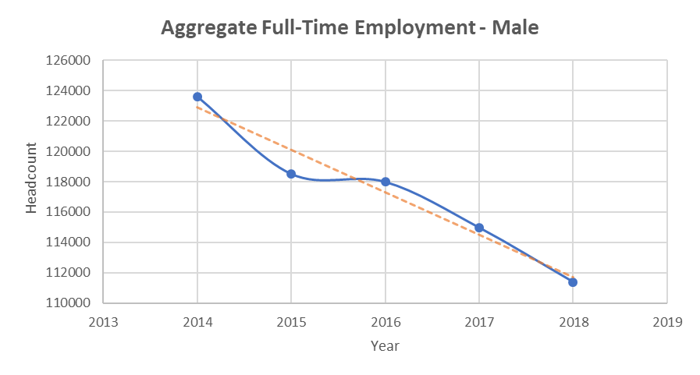

Figure : Trend in male full-time employment in the public sector. The trend shows an overall linear decrease.

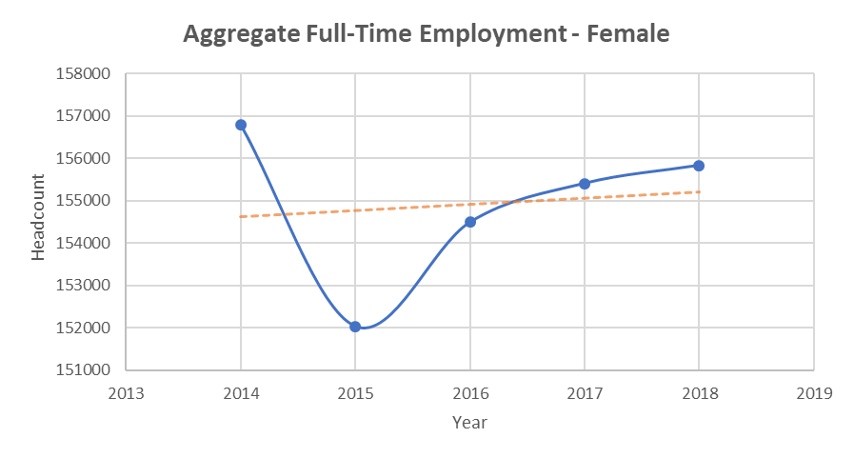

Figure : Trend in female full-time employment in the public sector. The headcount shows an increasing trend from 2015 onwards.

## Appendix B

## 

Figure : Trend in male part-time employment in the public sector. The trend shows an overall linear increase.

## 

Figure : Trend in male part-time employment in the public sector. The trend shows an overall linear increase. Note the oscillatory fluctuations in the female part-time employment participation.

## Appendix C

## 

## 

## 

## 

## 

## 

## 

## 

## 

## 

# Bibliography

|  |  |
| --- | --- |
| [1] | N. Cassidy and S. Parsons, “The Rising Share of Part-time Employment,” Reserve Bank of Australia, September 2017. [Online]. Available: https://www.rba.gov.au/publications/bulletin/2017/sep/3.html. [Accessed 19 December 2019]. |
| [2] | Australian Bureau of Statistics, “6102.0.55.001 - Labour Statistics: Concepts, Sources and Methods, Feb 2018,” Australian Bureau of Statistics, 12 2 2018. [Online]. Available: https://www.abs.gov.au/ausstats/abs@.nsf/Lookup/by%20Subject/6102.0.55.001~Feb%202018~Main%20Features~Employment~4. [Accessed 19 12 2019]. |
| [3] | NSW Government - Public Service Commission, “Workforce Profile Report 2017,” NSW Government - Public Service Commission, Sydney, 2017. |